Natural Resources Canada

A Program for the Development of Flood Damage (Vulnerability) Curves for buildings in Canada

Technical Report and User Guidance

2023-09-15

A Program for the Development of Flood Damage (Vulnerability) Curves for buildings in Canada

**Technical Report and User Guidance**

2023-09-15

**Prepared By: Prepared For:**

Natural Resources Canada

,

Phone:

**Our Ref:**

140078

________________________________________

David Sol, RPP

Associate – Manager, Planning

Contents

Acronyms and Abbreviations iv

Executive Summary 1

1 Introduction 1

1.1 Background 1

1.2 Flood Damage (Vulnerability) Curves for Buildings 3

1.2.1 Vulnerability 3

1.2.2 Vulnerability Functions 4

1.2.3 Financial Damages 5

2 The Program 5

2.1 Overview 5

3 The Master Rule Book 8

4 Xactimate Data Source 8

4.1 Valuation 8

4.2 Estimate 9

4.3 Price Lists 10

5 Determining the DDF Requirements 11

File Naming 11

6 Creating a New DDF 12

6.1 Creating New Estimate Data 12

6.1.1 Create a New Valuation and Info Sheet (residential) 13

6.1.2 Create Xactimate Estimate Data from a Valuation 7

7 Transferring or Updating an Existing Estimate 9

8 Using the DDF Templates 9

8.1 Grp3 9

9 Response Costs 9

10 Other 11

Tables

Table 1‑1 Arcadis Table Style 1 – simple lines 2

Table 1‑2 Arcadis Table Style 2 – banded rows 2

Table 1‑3 Arcadis Table Style 3 – data/tabular 2

Figures

Figure 1‑1 Figure Caption 3

Appendices

(Insert page break to increment Appendix Title)

Acronyms and Abbreviations

|  |  |
| --- | --- |
| DDF | Depth-Damage Function |
| FRA | Flood Risk Assessment |
| GIS | Geographic Information System |
| GLA | Gross Living Area |
| GO | Grade-Oriented |
| HVAC | Heating, Ventilation, Air Conditioning |
| NRCan | Natural Resources Canada |
| QGIS | An open-source GIS platform |
| SFD | Single-Family Dwelling |

Executive Summary

# Introduction

To advance and standardize floodplain mapping and mitigation planning in Canada, Natural Resources Canada (NRCan) has provided the Federal Flood Mapping Guidelines Series—a collection of evergreen resources addressing flood mapping and subsequent risk assessment uses. Building on the existing *Flood Damage Estimation Guidelines for Buildings and Infrastructure* and *Flood Risk Assessment Procedures*, the objective of the project is to develop a framework to produce standardized flood vulnerability data for buildings in Canada.

This report is not intended to replace or supersede these resources nor provide comprehensive guidance, procedures, or terminology related to flood risk assessment beyond what is related to the implementation of the project results. Readers are encouraged to familiarize themselves with the information available in the Guidelines prior to using the data or procedures described herein. Nonetheless, this introduction provides some common background information and terminology to define the scope and context of this project. The remainder of this report is organized in two main components, as follows:

(brief section summaries to be provided here once organized)

## Background

To enhance community resilience, planners must understand the risk. Therefore, quantitative risk assessments are essential for evaluating a community's capacity to adapt to flooding events and the effectiveness of mitigation strategies.

To assess any risk effectively, two crucial elements must be considered: the likelihood of an event occurring and the consequences if that event materializes. For instance, a major flood event that submerges a house to a depth of one meter on its main floor may be deemed rare in occurrence (low likelihood). However, the potential for significant property damage and substantial repair costs in such an event underscores its high consequence. Conversely, another house might experience less severe but more frequent flooding (higher likelihood), resulting in lower property damage and repair costs (lower consequence) per event.

The extent of flood consequences to an asset, such as a house, is a product of two variables: exposure to the hazard (e.g., floodwater in a building) and the vulnerability of that asset to that exposure (e.g., susceptibility to water damage). Without exposure or vulnerability, there are no consequences and thus no risk, regardless of the hazard.

Quantifying risk with consequence probabilities allows us to gain a nuanced understanding. It helps us discern whether minor basement flooding occurring regularly or the possibility of a rare but devastating flood is of greater concern. Depending on the metrics we prioritize, such as property repair costs or life safety, our risk assessment may lead us to different conclusions.

The simplified concept of risk as a product of hazard, exposure, and vulnerability emphasizes that all three components are essential. Only when exposure and vulnerability are present does the risk emerge. By adding probability to the hazard, we can quantitatively assess the risk and prioritize mitigation efforts based on our specific objectives.

Additionally, the risk framework of hazard, exposure, and vulnerability provides a basis for risk modeling. Estimating flood exposure, consequences, and risk requires spatial analysis to determine exposure levels, and object-based (per-asset) assessments involve a significant number of calculations. Figure 1‑1 illustrates the interrelationships among these risk variables and inputs within a typical asset-based risk model.

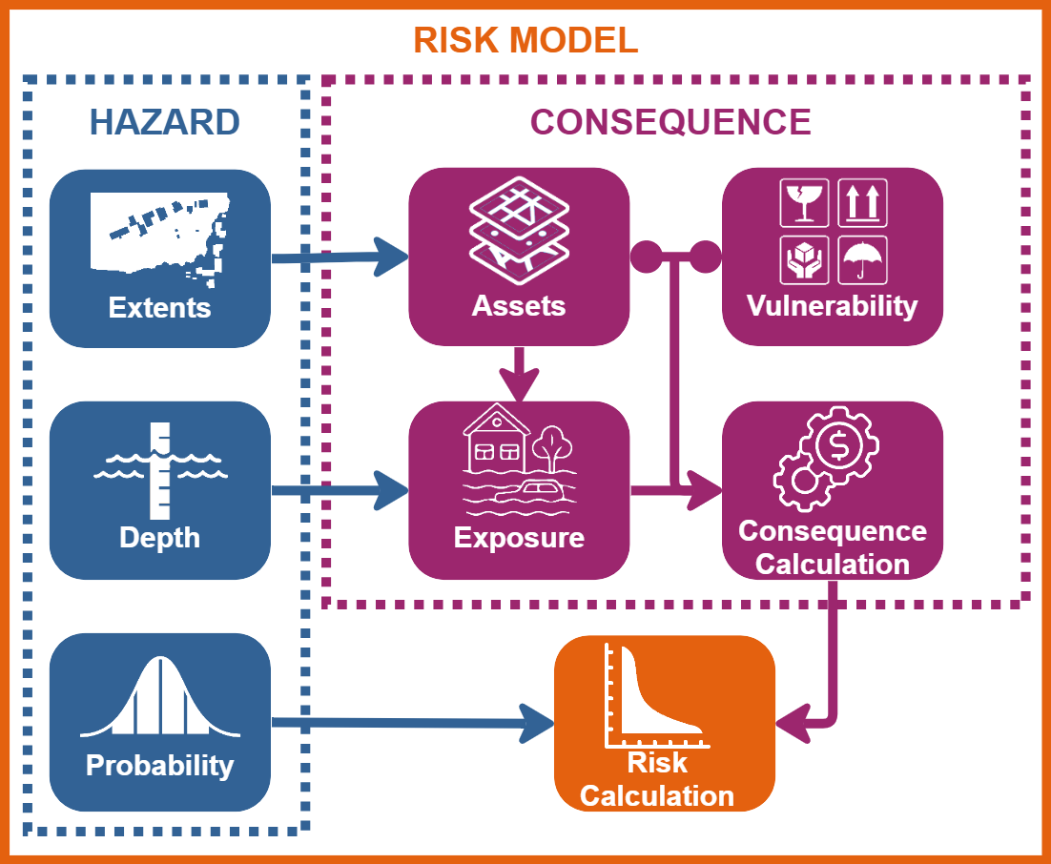

Figure 1‑1 Object-based flood risk model conceptual diagram in which assets are linked to available vulnerability data to estimate exposure consequences.

Recognizing the need for accessible and standardized risk assessments, NRCan has developed CanFlood, Canada's open-source flood risk modeling toolkit, available as a QGIS[1] plugin within the QGIS repository and on GitHub. Documentation and tutorials are also accessible on the GitHub platform. [2]

The reliability of CanFlood's results and its ability to inform critical planning decisions hinge on the quality, clarity, and relevance of the input data. While hazard data[3] quality and awareness of the direct and indirect consequences of flooding have improved over time, the availability of current, clear, and applicable exposure or vulnerability data remains a substantial impediment to effective risk assessments.

Although numerous studies and methodologies have been undertaken since the late 1960s to assess flood damages within affected communities across Canada, the development of standardized vulnerability data to quantify consequences has been inconsistent, resulting in a fragmented landscape of approaches, represented assets, and data sources. This fragmentation has limited the transferability of data and introduced significant uncertainty when quantifying risk and evaluating mitigation strategies.

In response to this challenge, NRCan has initiated this " Program for the Development of Flood Damage (Vulnerability) Curves for Buildings in Canada" project.

## Flood Damage (Vulnerability) Curves for Buildings

This section outlines the scope and metric of the vulnerability considered for this project and the terminology used to describe it.

### Vulnerability

In the preceding section, the susceptibility of a house to water damages was provided as an example vulnerability. Vulnerability, however, is vastly complex and dynamic, consisting of interrelated tangible and intangible dimensions. The Sendai Framework Terminology on Disaster Risk Reduction defines vulnerability as “the conditions determined by physical, social, economic and environmental factors or processes which increase the susceptibility of an individual, a community, assets or systems to the impacts of hazards.” (United Nations General Assembly, 2016)

Assessing vulnerability is an essential step towards understanding and quantifying the consequences and then risk of flooding. The FRA literature provides several frameworks illustrating the complex dimensions of vulnerability across interdependent systems. However, accurately capturing all of society’s interactions with flooding as part of a practical FRA is simply not feasible, and attempting to with available resources would likely not yield any reliable or helpful information for community planners. Instead, FRAs in practice typically acknowledge the limited understanding of vulnerability and available data and rely on a core set of one-dimensional object-based indicators or quantifiable metrics. The limited metrics can then be supplemented with value-based multi-criteria frameworks when employed for local planning decisions.

Buildings and their potential flood damage costs are the most common exposed asset and financial consequence for FRAs. Buildings are perhaps the most tangible spatial representation of a community’s exposure to flood hazards and tangible source of direct financial consequences. Buildings also represent or accommodate many other aspects of life including, but not limited to our:

* Homes and workplaces
* Investments as owners, financiers, or insurers
* History, culture, community, and faith
* Public institutions such as education, healthcare, governance, and social services
* Environmental footprint
* Recreation and commercial services

Therefore, exposure and damages to building assets is a foundation upon which to understand a wider range of direct, indirect, tangible, and intangible local or system consequences and risks of flooding. This makes the establishment of a standardized, transparent, and adaptable building damage methodology and data source critically important to advancing our assessment of the wider range of consequences.

### Vulnerability Functions

For flood risk modelling, ‘vulnerability function’ is a general term to describe a relationship between hazard exposure and resultant consequences for any asset. For buildings, this could be the one-dimensional relationship between the depth of water and the repair costs and the common interchangeable terms of depth-damage or stage-damage curves. This report will use the term damage function to refer to a general subset of vulnerability estimation involving property damage relationships (could include velocity, waves, ice), and depth-damage function (DDF), in reference to specific functions considering only depth and property damage.

Empirical models use a data-driven approach, relying on actual damage datasets from past events to link building vulnerability to the record of damage data of the flood event. Synthetic curves are generated based on a conceptual approach and expert knowledge, hypothesizing, and making assumptions about the potential damage, related to specific components of the building.

Direct depth-damage functions are typically composites, representing aggregate damages for an archetypical building, expressed either per structure or scalable by area (e.g., square meters). Structure and content damage functions are typically separate functions, with structure damage referring to all the building components and finishes that would not normally change with a change in occupancy (e.g., flooring, cabinetry, water heater, furnace).

As illustrated in Figure 1‑2, depth values for object based DDFs are typically relative to a building’s main floor because the exposure to flood depths is dependent on the height of the main floor from grade.

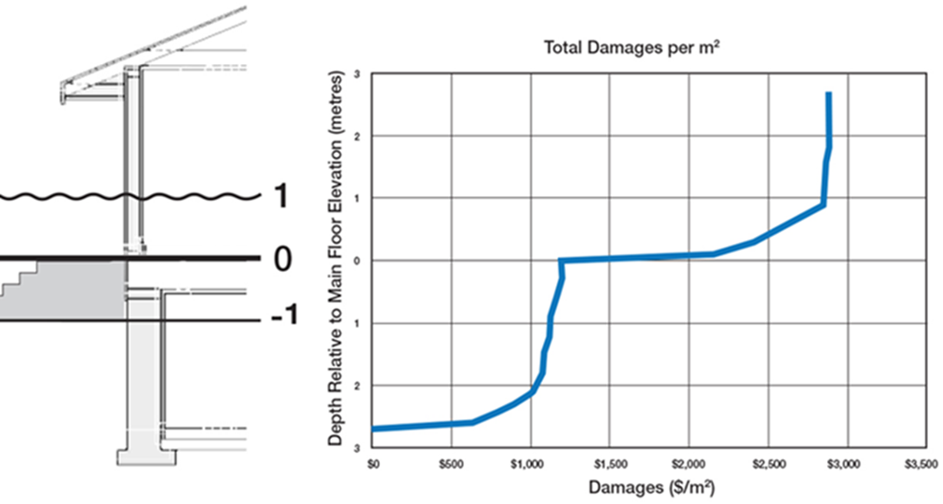

Figure 1‑2 Illustration of a stage-damage function based on depth and damages per square meter relative to main floor.

### Financial Damages

When estimating monetary flood damages, there are two main appraisal perspectives, defined by Messner (2007) as follows:

* **Financial**: the aggregate “damage from a perspective of a single person or firm, neglecting public affairs and focusing on the actual financial burden”; or
* **Economic**: “the impact on national or regional welfare, including impacts on intangible goods and services”

A theoretically equitable risk assessment for ‘society’ would need to define ‘society’ and then employ an economic appraisal within that boundary. This would include consideration of depreciated values for property destroyed by floods – In a situation where a flood destroyed a five-year-old television, the wider economy would lose a five-year-old television of depreciated value; but would likely gain the purchase of a new television of even greater value. Similarly, it would consider the potential benefits for contractors and suppliers involved in restoration, businesses providing substitute capacity for those directly affected, and even the future benefits of new material and equipment for affected property owners.

The spatial and temporal complexities and “winners and losers” reality of economic assessments should not be considered at the level of the individual damage function. While it is possible to purchase an equivalent used replacement television, it is not possible to re-apply five-year-old paint; and data on the respective age of building finishes and contents is not readily available and would be constantly changing. Therefore, the financial approach for property damage which utilizes current replacement and restoration costs is most appropriate for damage functions. The financial perspective provides consistency and supports the application of depreciation or other factors where appropriate for subsequent economic analysis.

This scope of this project is limited to direct building structure damages (restoration, repair, or replacement costs). However, the proposed framework was developed to be expandable and flexible to include future work and knowledge of a much broader range of vulnerabilities.

# The Program

This project presents a new approach for the creation, manipulation, and updating of DDF data. Rather than providing another static set of new composite damage estimates, the creation and maintenance of damage information is based on a dynamic database of flood vulnerable items and exposure-replacement rules. The rule set can then be used with local study inventory items and pricing information to compile the relevant set of damage functions.

## Overview

The overall process can be generalized in three main components:

* asset or component inventory with current local prices or other appropriate metrics,
* master rule book to lookup current damage rules for all inventory items,
* calculation of current depth-damage values for each item and compilation of damage functions.

This process and role of the master rule book are conceptually illustrated in Figure 2‑1.

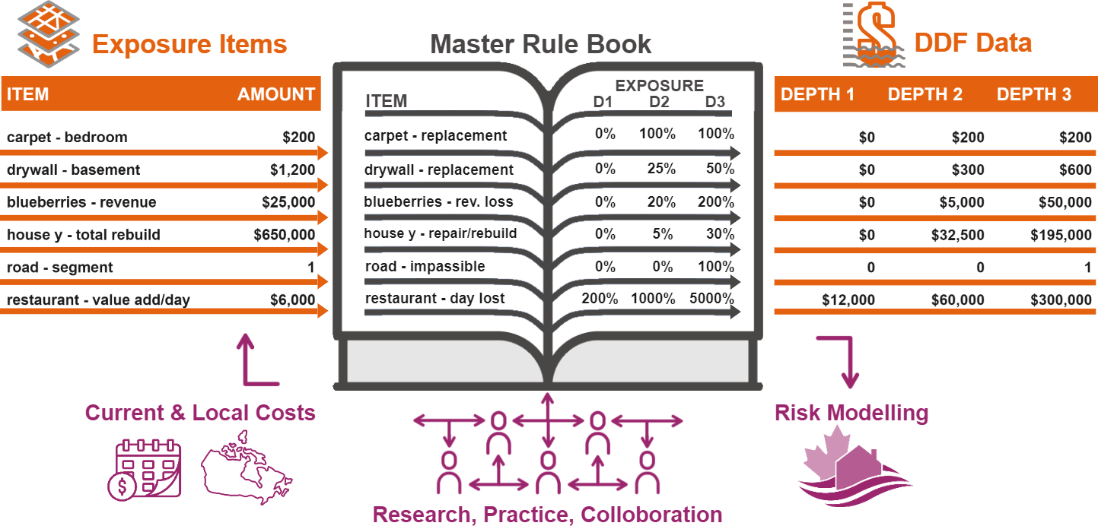

Figure 2‑1 Conceptual illustration of master rule book for various item lookups

The information shown in Figure 2‑1 is simplified and hypothetical with the intent to illustrate some of the key differences between the proposed damage function process and the traditional use of existing damage functions. The main distinction is the introduction of a process to

* facilitate the creation of current, local damage functions, and
* facilitate the collaborative, multidisciplinary accumulation of vulnerability knowledge through the provision of a central transparent rule set.
* separation of damage data into two parts: a non-monetary consequence rule (e.g., percentage replacement cost) and the resultant monetary cost based on local current conditions. This provides several important advantages, including:
  + Independence: the non-monetary rules are independent of spatial and temporal conditions that influence the creation of static DDFs at a certain time and place. A depth-replacement rule for carpet, for example, should be valid for either a fine wool carpet in Hamilton 2005 or budget polyester in North Vancouver 2030. the independent rules can be applied to limitless price lists or variations of materials they represent. This characteristic is fundamental to the primary objective of the proposed process, which is the provision of a dynamic, expandable, and evergreen source of damage function data.
  + Transparency: the collection of rules provides key information about how the final costs were derived. This information can also be used for further vulnerability research and sensitivity analyses.
  + Adjustable: the rule set provides a clear and accessible variable to which important adjustments can be made. This includes refinement over time collectively based on evidence as it becomes available, but also for individual studies and various objectives. The component-level rules are inherently a combination of the item’s vulnerability to water damage as well as the exposure within the asset. Therefore, the user can adjust the depth rules individually to account for detailed changes in exposure and vulnerability variables.
    - Exposure: The influence of location assumptions can be demonstrated with carpet flooring and drywall. Both may have high vulnerability to water damage (assume 100% replacement for exposed material), however, with the assumed locations of each, 3 cm of floodwater would expose 100% of the carpet flooring and approximately 1% of drywall on the walls (or 2% of a horizontally hung standard 4x8 sheet) and 0% of drywall on the ceiling.   
      Components can therefore have multiple entries. For example, batt insulation may be located beneath the floor in a crawlspace, within the wall cavities, and in the attic.   
      Component exposure adjustments for individual studies is particularly useful for mechanical items, such as water heaters, furnaces, and electrical panels, to assist in the evaluation of floodplain building regulations.
    - Vulnerability: Although the rules are intended to be applicable to any variation of the same item (assuming carpet is carpet, as noted above), there may be circumstances for which adjusting the percentage replacement would be based on vulnerability, rather than location.
* The ‘exposure items’ can be of any detail level, type, or metric, provided that an appropriate depth-damage relationship can be utilized.
  + Detail level: at the level of individual building materials and finishes, such as carpet and drywall, the rulebook can be used to compile a DDF for a room or entire house, both of which can also coexist as aggregate functions within the rule book. i.e., one can use a local current building component price list to compile a new composite DDF for a structure at a particular time and place and that compiled DDF can then be stored within the rulebook (either as a composite rule or local costs).
  + Type: along with items of various levels of detail or aggregation, the rule book approach to data can also facilitate DDF creation for non-building assets and indirect damages. Blueberries, for example, can have several associated rules, such as a percentage of revenue lost. Indirect damages, such as business interruption, can be associated with a depth-duration relationship.
  + Metric: the depth rules are not limited to monetary metrics.

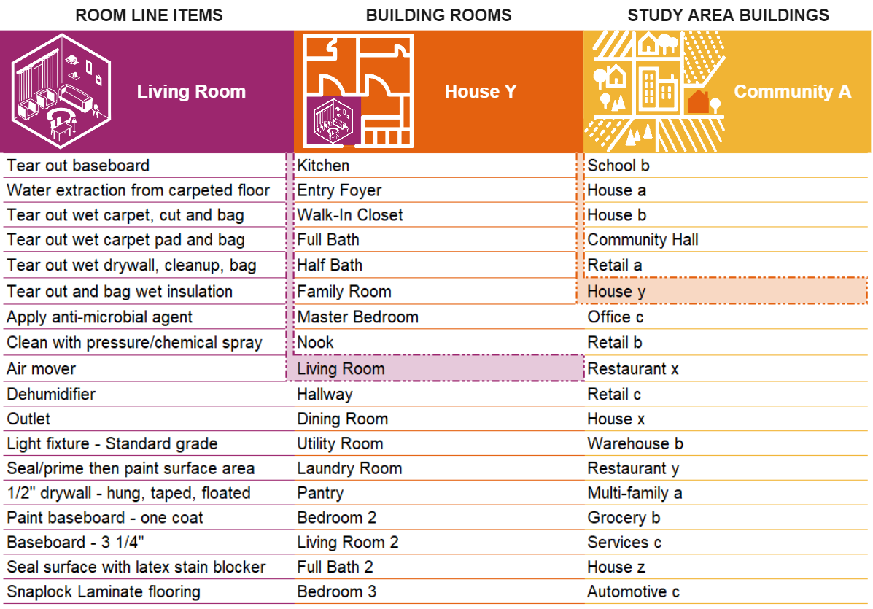

# The Master Rule Book

For this first phase, the ‘master rule book’ is in the form of an Excel workbook. If the concept proves to be effective and is expanded, a database solution would be more appropriate. The rule book is currently intended to serve the following functions:

(diagram of uses, workflow)

# Xactimate Data Source

## Valuation

Valuations are based on the same component-level pricing as the claim-level Xactimate estimates. However, rather than requiring the creation of a detailed model for a specific building, the valuation program only requires the entry of key characteristics, from which all the components are compiled based on property databases and claims.

The valuation products are typically used by insurance companies to evaluate their total exposure as well as at the claims level for total loss situations (complete rebuild).

Valuations can be created in both the desktop and online versions of Xactimate. The online version features direct access to another stand-alone Verisk product, 360Value, while the desktop valuations are conducted within the Xactimate application. Both versions require the entry of similar key building attributes, However, there are some noted differences between the two for the purpose of creating DDF data. Upon initial testing of both versions, the online version was chosen to complete the valuations for this first version of the program. A key difference was noted in the results when converted to a component-level estimate.

The desktop version provided estimates with components grouped by component categories and the online 360Value version provided estimates with components generally grouped by room, as illustrated in Table 4‑1.

Table 4‑1 comparison of Xactimate valuation component grouping

|  |  |
| --- | --- |
| Desktop Valuation | Online Valuation (360Value) |
| Appliances | Structure Level* |
| Interior Finish | Bathroom |
| Floor Covering | Bedroom |
| Heating/AC | Utility Room |
| Plumbing | Kitchen |
| Electrical | Living Room |
| Roofing | Dining Room |
| Windows | Nook |
| Exterior Finish | Hallway |
| Rough Framing | Laundry Room |

*see Section XX

The online version was selected due to the requirement to allocate the items spatially within the building for the DDFs. Not all items will be exposed to the various potential flood depths (e.g. basement versus second floor bathroom) and their grouping by room allows them to be situated appropriately according to the layout of the architype buildings (see Sections XX and XX).

Note for future work:   
A detailed analysis of the differences between the two versions was not conducted. The desktop version may have other benefits not explored.

## Estimate

## Price Lists

|  |  |  |
| --- | --- | --- |
| Province | Location | Xactimate Code |
| Alberta | Calgary |  |
|  | Edmonton |  |
|  | Fort McMurray |  |
|  | Grande Prairie |  |
| British Columbia | Kelowna |  |
|  | Prince George |  |
|  | Vancouver |  |
|  | Vancouver Island |  |
| Manitoba | Brandon |  |
|  | Winnipeg |  |
| New Brunswick | Fredericton |  |
|  | Moncton |  |
|  | Saint John |  |
| Newfoundland & Labrador | Corner Brook |  |
|  | St. John's |  |
| Nova Scotia | Halifax |  |
|  | Sydney |  |
| Ontario | Barrie |  |
|  | Burlington |  |
|  | Kingston |  |
|  | Kitchener |  |
|  | London |  |
|  | Ottawa |  |
|  | St. Catherines |  |
|  | Sudbury |  |
|  | Thunder Bay |  |
|  | Toronto |  |
|  | Windsor |  |
| Prince Edward Island | Charlottetown |  |
| Quebec | Abitibi |  |
|  | Cantons-de-l'Est |  |
|  | Grand Nord |  |
|  | Montreal |  |
|  | Montreal-Nord |  |
|  | Montreal-Sud |  |
|  | Outaouais |  |
|  | Rimouski |  |
|  | Saguenay |  |
| Saskatchewan | Regina |  |
|  | Saskatoon |  |

# Determining the DDF Requirements

Description and workflow diagram

### File Naming

With the large amount of data being created and shared, consistent file naming is important. A DDF naming convention should produce unique and descriptive filenames indicating the type of file, type of asset, and type of vulnerability.

During the conception, development, and production of the pilot set of functions, a naming convention was adopted to organize the files within and between the DDF datasets. The structure that emerged was effective for the work completed. However, it was not subject to further analysis or review, and it is acknowledged that it may have future limitations or there are otherwise more effective options not considered.

The naming structure used for the DDF deliverables is also used throughout this section and is outlined below. Note that the examples are drawn from the pilot set and are thus also limited to residential houses.

The base name is derived from the primary building attributes. It is intended to be used for a range of applications that are independent from file type and location. It describes the architype generally by the attributes and structure as illustrated with the examples in Table 5‑1.

Table 5‑1 Base Name components and examples

|  |  |  |  |  |  |  |
| --- | --- | --- | --- | --- | --- | --- |
| Category | Storeys | Size | Foundation | Basement | Quality | Base Name |
| residential (R) | one (1) | small (S) | crawlspace (C) | n/a | economy (EC) | R_1-S-C-EC |
| two (2) | medium (M) | basement (B) | undeveloped (U) | standard (ST) | R_2-M-BU-ST |
| large (L) | developed (D) | above avg. (AA) | R_2-L-BD-AA |
| custom (CU) | R_2-L-BD-CU |

Additional suffixes are then added to the base name to designate the files (or worksheets within a workbook) associated with or produced from that base archetype, as illustrated with the examples in Table 5‑2.

Table 5‑2 Example of names and files used for DDF construction.

|  |  |  |
| --- | --- | --- |
| Name Type | Name Code | File Type |
| **base** | **R_2-L-BD-AA** | |
| info sheet | R_2-L-BD-AA_info | .xlsx (worksheet) |
| valuation | R_2-L-BD-AA_VAL | .esx (Xactimate) |
| valuation report | R_2-L-BD-AA_VAL | .pdf (Xactimate export, documentation only) |
| composite DDF compiler | R_2-B | .xlsx (worksheet) |
| location | _ABCA | n/a (code from pricelist, see section XX) |
| estimate | R_2-L-BD-AA_ABCA | .esx (Xactimate) |
| estimate line-items | R_2-L-BD-AA_ABCA | .xlsx (Xactimate export) |
| estimate report | R_2-L-BD-AA_ABCA_rep | .pdf (Xactimate export) |
| estimate report | R_2-L-BD-AA_ABCA_rep | .xlsx (PDF report exported to Excel) |
| DDF workbook | DDFwork_R_2-L-BD-AA_ABCA | .xlsm (macro-enabled workbook) |
| CanFlood DDF - area ($/m2) | R_2-L-BD-AA_struct | .xlsx (worksheet) |
| CanFlood DDF - total ($/structure) | R_2-L-BD-AA_m2 | .xlsx (worksheet) |

Note that the Xactimate application restricts filenames (.esx) to upper case, which is reflected in the names of related files either directly exported or created for consistency.

# Creating a New DDF

As described in Section XX, there are several ways to generate or use Xactimate estimate data with the rule book to create a new DDF. This section includes instructions for the following:

1. Creating Xactimate estimate data for:

* a new building type or configuration,
* a new pricelist (location and/or time) using an existing estimate,

1. Creating a DDF:

* with new estimate data
* with an existing DDF template

Actions or descriptions with corresponding screenshot examples are indicated with the Unicode “Print Screen” symbol (**⎙**) and are provided in Appendix B by

## Creating New Estimate Data

The following steps were used to generate new Xactimate cost data for a new building type or configuration:

* Create a new valuation and info sheet (using Xactimate online with 360Value).
* Convert the valuation to an estimate.
* Export and save the data package for use with the DDF templates.

The procedure for each of the above steps is provided below.

### Create a New Valuation and Info Sheet (residential)

Using the Valuation feature of Xactimate is an efficient means of generating a detailed estimate based on general building attributes. The descriptions in this section relating to the use of 360Value are limited to the residential valuation type. The application also includes valuations for Commercial, Agricultural, Condo, and Manufactured home categories.

The user-entered and application-generated valuation attributes are a basis for final component and cost lists generated by Xactimate.

However, the outputs of the valuation and subsequent estimate do not include all the attributes and assumptions required to produce the associated DDF data. Therefore, a separate Excel information sheet is completed concurrently. In addition to recording the 360Value entries, it stores other information required for the next DDF steps, as summarized in Table 6‑1.

Table 6‑1 Summary of info sheet contents

|  |  |  |  |
| --- | --- | --- | --- |
| Info type/section | Entry Step | Source | Purpose |
| Name/code | Info sheet creation | User. A preliminary naming structure is described in Section XX. | The estimate naming convention should uniquely and descriptively identify the archetype for files from valuation through DDF creation. |
| Estimate parameters | In Xactimate after conversion of valuation to estimate. | User, replacing Xactimate defaults | These parameters globally change the line-item costs and thus need to be recorded with the DDF. |
| 360Value entries | As valuation is completed | User primary entries plus mix of 360Value defaults and user modifications and additions. | Some attributes are directly used for the DDF creation, others are for archetype record and reproducibility. |
| Valuation room levels | As valuation is completed with potential revisions during DDF process. | User and 360Value. | The room level (basement, main, upper) is critical for the alignment of the DDF relative to main floor. |

The draft info sheet template provided with the master rule book indicates which fields are required by the DDF routines with red cell borders. The remaining fields are recommended to provide a record of the archetype’s creation and for reproducibility.[4]

*Note that the valuation process is used to generate the estimate items, not the costs. The valuation results such as cost per finished square foot and the cost breakdown by category will differ from the estimate when the parameters are changed.*

The steps below are organized according to the 360Value screen. The 360Value input screens contain links for additional information on field or description values. Typically, each field name can be clicked for a brief description that also includes a “more...” link for greater detail and/or illustrations.

This instructional information is valuable but will not be repeated here. The 360Value screens are generally easy to navigate, however readers of this report without access or experience with 360Value may benefit from seeing some of the process. Therefore, many of the screenshots (**⎙**) for actions within this section were added to be illustrative, rather than instructive.

Similarly, later users of the completed work may wish to better understand the descriptive terms (e.g., “economy grade”) or item names (e.g., “solid surface” countertops). A selection of relevant 360Value definitions and illustrations has also been provided in Appendix C.

The following steps describe the creation of a new valuation:

1. Make a copy of the info sheet template to accompany the valuation and subsequent DDF work. A blank info sheet can be copied from the master rule workbook[5].
2. Enter the primary file information for the DDF you are developing, including the base name and its constituent attributes (Table 5‑1).  
   Change the worksheet name (tab) to match the base name plus the “_info” suffix.
3. In Xactimate online, select New Project.
4. In the new project window, complete the fields as follows and then create:

* *Profile*: Contractor
* *Project* Type: Valuations (360Value)
* *Valuation type*: select building type.
* *Project Name*: recommended BASENAME_VAL.

1. Open the new valuation. It will open in a new browser tab.
2. **Policy**: These fields can be left with the default name and blank claim information.
3. **Address**: Only the postal code is required for the valuation, as it is the source of the price list lookup. However, when converting to an estimate, an address is required so it should be entered at this step.

For the pilot set of generic estimates, a fictitious address (123 Flood Way) and the postal code of a public location (e.g., municipal building) was used.

1. **Primary Information** **⎙:** These fields are where the main attributes that determine the construction of the archetype’s components begin.

* *Year Built*: An area average or default year-built can be entered. For the pilot study set, the year 2000 was used.

When developing current replacement estimates, the year-built value entered is not as important as it may seem. Replacement estimates are financial costs for the property, rather than economic assessments that would consider time-depreciated values (see Section 1.2.3). Furthermore, depreciation would be based on “effective” age, considering updated and replaced components, rather than the structure’s original year built.

For general replacement cost estimates, year built is primarily an indicator that a structure may have components predating periods of major changes with mass production and standardization of building materials and practices. The most significant change was around the end of WWII with off-site manufacturing of major components, such as engineered trusses and panel products (e.g., drywall and sheathing), and then later with continued material changes, particularly the replacement of wood components with new alternatives that are more economical or durable (e.g., MDF trim, aluminum soffits, vinyl flooring).

There are two restoration approaches that impact the cost for buildings with historic construction materials and methods:

* Actual replacement cost: rebuilding with the same materials and methods as the original (to the extent material and trades are available and is code-compliant). This approach is typically very labour intensive and relatively expensive.
* Functional replacement cost: rebuilding with current materials and methods to achieve an equivalent function and appearance. This approach is less expensive than actual replacement.

360Value provides the option to use functional replacement costs if the year built entered is prior to 1986. If generating an historic building DDF for which reproduction of the original construction is of cultural significance, the original year-built date can be used without functional replacement selected.

* *Total Finished Square Feet*: This value should be consistent with industry standards (e.g., ANSI Z765) for measuring and reporting Gross Living Area (GLA), which includes all above-grade finished and conditioned areas, measured from the outside of the structure (including walls).  
  For DDF construction, it is important to remember that for most buildings, this does not equate to the “footprint” or main floor area. The distribution of multi-level GLA is addressed in the DDF templates (see Section XX)
* *Home Quality Grade*: The overall home quality grade entered at this stage influences the application’s selection of the building’s features, components, and component grade. There are four categories each with five quality levels to choose from:

**Categories**

General shape and style

Exterior features and finishes

Interior features and finishes

Cabinets and countertops

**Grades**

Economy

Standard

Above Average

Custom

Premium

The application automatically determines an overall quality based on the combination of grades selected for the categories. Therefore, it is recommended that a single quality grade be applied to all categories for clarity. Further details on the quality categories employed by 360Value are available in Appendix C.

**Primary Information (cont.) ⎙:** The second set of primary information contains the remainder of the minimum information required by 360Value to calculate a total replacement value estimate. These fields are all pre-populated based on the previous input. Some of the fields will have a significant influence on the components included in the DDF calculation while others will not.

Use, number of storeys, and foundation type and finish directly reflect the archetype’s base name components and will determine the finished area layout for the DDF.

* *Use:* For residential valuations, the choices include individual units (single-family detached, attached end unit, attached interior unit), and combined units (multi-family duplex, triplex, fourplex). For individual units, the primary total valuation variable would be the extent of exterior walls. The selection of combined units, on the other hand, would generate multiple primary rooms, features, and utilities within the GLA previously entered. A combined duplex structure, for example, would include two kitchens, two HVAC systems, two entries, and so on.
* *Number of Storeys, Foundation Type, Percent of lowest level finished:* Ensure that these entries match the archetype’s description in the info sheet. If including a developed basement in a new general archetype, 100% finished is recommended for clarity and consistency.

|  |
| --- |
| **Grade-Oriented (GO) Residential Units**  *Grade- (or ground-) oriented is a term for buildings with entries to grade for each unit. This includes all buildings individually referred to as single-family, semi-detached, or row/townhouse.*  *The GO pilot DDFs were all based on SFD valuations. The variation in exterior features and finishes (e.g., siding, trim, windows) on one or two side walls (end or interior unit) for attached units was assumed insignificant for flood damages relative to other variations.*  *Assuming an individual unit is well represented by a DDF regardless of its “relationship status”, the treatment of attached units is more flexible. However, it is also illustrative of the scale issue inherent in the typical application of DDFs to building exposure inventories.*  *The image below is an example of five building polygons representing 28 residential units.*  A group of orange squares  Description automatically generated *If the DDF scale is $/m2 based on an SFD archetype matching the units, the total building area can be used because it will effectively repeat the units appropriately (i.e., proportion of kitchen, bathroom, mechanical). In this case, the weakness of $/m2 scaling for individual units is a strength (see section XX)*  *On the other hand, if the DDF scale is per structure and the inventory isn’t manually split into 28 or the scale modified, the results could be 5/28ths of the exposed value.* |

The completed set of functions were based on estimates considering depth only (low velocity), with damage primarily caused by temporary submersion, contact, or moisture from floodwaters. Under such conditions, it is assumed that water-damaged items can be replaced, and many structural components are not critically affected (e.g., framing and trusses, exterior siding, roofing, windows). This is reflected in the items and associated rules in the rulebook, some of which are directly related to inputs on this screen. The current rulebook entries for these components have them marked for exclusion in the DDF scripts.

Water contact or submersion is the most universal cause of property damage. However, other forces (e.g., hydrostatic, hydrodynamic, buoyancy) can cause additional damages or complete structural failure in extreme flood conditions (e.g., high velocity, surge or waves, ice or debris, scour or erosion). Therefore, total loss details may be of importance.

* *Exclude Foundation Values*: This option is relevant for insurance use of the application. If, for example, a house destroyed by fire had a solid concrete foundation, rebuilding on that foundation may be viable and the “total loss” valuation would exclude the costs to rebuild it. If constructing a damage function to include structural failure, the foundation costs can be included by unchecking this option.
* *Exterior walls and roofing fields*: For depth-only DDFs, the default entries are likely appropriate. However, if creating functions for total loss, ensure the values are representative of the target archetype.
* *Garage/Carport:* The inclusion of a garage at this stage is optional. If a garage is included in the valuation, the components should be grouped and handled independently at the DDF creation stage. If a garage is incorporated into the same DDF as the house, this should be clearly indicated. The pilot set of residential DDFs excluded garages. A separate set of valuations was created to extract only the garage components for garage-only DDFs.

|  |
| --- |
| **Attached Garages** |

* Of the finish and material entries on this screen, floor covering is the most relevant for inclusion in DDF values. The entry format for items such as flooring allows for the selection of multiple types at percentages of the total area. This reflects reality as it is common for a home, for example, to have wood in the living room, tile in the bathroom, and carpet in the bedrooms. However, it also presents a departure from reality, both in the way the application distributes flooring among room groupings when converted to an estimate, as well as the way it can be used to produce averages for DDFs.

If a home’s flooring is 50% hardwood plank, 20% ceramic tile, and 30% carpet, the total replacement cost is readily estimated without concern for what is in each room. The valuations are intended for total replacement costs, not by room, and the cost breakdown in the valuation reports is appropriately categorized, as in the example below.

Figure 6‑1 Example cost breakdown from 360Value report.

However, we are then using the valuation’s data to generate estimate line items for components within these categories and location within the building. As discussed in Section 4.1, Xactimate desktop valuations produce estimate data grouped as shown in Figure 6‑1 when converted, while estimates from online (360Value) valuations are grouped by room. The online version was chosen for DDF data because the rooms could be assigned to a floor level and depth relation.

An understandable (for purpose) quirk of converting total flooring by percentage to room data is that 360Value applies that ratio to every room. In other words, the bathrooms, kitchen, and bedrooms would all have 50% hardwood plank, 20% ceramic tile, and 30% carpet. While this is rather unrealistic, it is not consequential for a valuation, nor a DDF for rooms on the same level as all would have the same depth exposure.

It could, however, misrepresent material exposure in the case of basement flooding in a house with premium carpet on the second floor, exotic hardwood on the main, and rubber tiles in the basement. This is noted primarily for perception due to the level of detail available in the produced data and a reminder that we are generating a very robust package of items and costs for a representative building – not designing one. These valuation characteristics can also be taken advantage of to cover the wide range of materials, such as flooring that may be found within the same block of houses, if not an individual one. A blend of flooring types that fit the archetype can be used to effectively create an average cost, as illustrated in Figure 6‑2.

Figure 6‑2 360Value entry of multiple flooring types for an average cost

Kitchens and bathrooms are primary rooms because they contain most fixtures and finishes and thus costs. Therefore, they are the only rooms included in the Primary Information required before a valuation can be calculated. The remaining room information can be viewed and edited in the optional sections covered in the next step. As with all rooms, it is important to ensure that the assumed floor level is recorded in the info sheet.

Rooms are shown in the main screen by name, size or type, and count. Room details are visible and edited by clicking on the Enter Details link below the room type.

* *Kitchens:* Kitchen details are prepopulated based on previous entries. However, the entries should be reviewed to ensure they reflect known local standards for the type and that the appliance list is complete. For example, in completing valuations for the pilot set of residential functions, it was found that the program consistently included garbage disposal unit in the appliances but omitted a refrigerator.   
  For general archetypes it is safe to assume that the kitchen is on the main level. However, secondary suites are increasingly common in basements of SFDs and would greatly increase flood consequences. If creating a DDF that includes a secondary suite, a second kitchen can be added here.
* *Bathrooms:* As with kitchens, review the prepopulated attributes and edit as desired. If a developed basement is included, the program will typically assign a bathroom to the basement if appropriate for the size/quality selections. For two-storey houses, there is no indication of main or upper-level location of bathrooms. However, the level of each bathroom needs to be entered on the info sheet at this stage, as covered with the other rooms in the next section.
* *Site Access:* The surrounding site conditions can add costs due to access constraints for delivery of materials, staging, or interruption of public walkways or roads. For a generic DDF, average – no unusual constraints is recommended. Other options include island access, rural/remote, and urban access.

The valuation can be completed after the second primary information screen. However, the optional details section provides additional information to document the DDF and the room information subsection is important for the DDF layout process.

1. **Optional Details ⎙:** The optional details screen includes the seven subsections below:

* Exterior: roof construction, specialty windows, specialty trim and details.

Verify and record the default entries in the info sheet.

* Interior: walls, ceilings, electrical, specialty systems.

This subsection contains several key attributes, including the interior finishings and heating, cooling, and electrical systems. Ensure that these selections are regional appropriate for the DDF. Note that average wall height is included, which should be matched when compiling the function by heights.

* **Room Information**: Bedrooms, Dining Rooms, Laundry Rooms, Utility Rooms, Sports Courts.

Verifying, recording, and assigning room location (level/floor) is the most important subsection. Expanding the room information tab shows a list of rooms grouped by type and size as shown in Figure 6‑3. Click the Enter Details link to view, edit, and record room info for each group.

Figure 6‑3 select Enter Details for each group of rooms.

The room details include a check box to indicate basement room but otherwise do not explicitly include location or floor level. It is recommended that for each archetype, a representative floorplan be used as a guide to complete the room details. Floorplans and other building details are readily available online. Sources include real estate listing and sites that specialize in selling building plans.

Assumptions for typical room locations are relatively easy to make with an understanding of typical layouts for the size and style. For example, a standard two-storey house with developed basement may be populated with five bedrooms and three full baths and one half-bath. A reasonable assumption would be three bedrooms on the second floor, one with a full bath ensuite and the other two sharing a second full bat, and two bedrooms in the basement sharing the third full bath, leaving the half-bath to serve the main floor with no bedrooms.

Other clues as to the layout default from Value360 can be gleaned from the room features. If, for example, a bedroom in a two-storey house features vaulted ceilings, it is likely on the upper floor. On the other hand, if an entry foyer features vaulted ceilings, we know it is on the main floor so it must be open to above – and thus the second floor has reduced area in relation to the main.

Once the room details are completed in the valuation and the info sheet, the CALCULATE NOW button can be selected.

1. **Results**: The results screen displays the total estimated replacement cost and some information options. As stated above, these results are not used in the DDF construction. Instead, we are using the valuation to generate the components for pricing and depth allocation. However, the valuation details provide a record of the process, and the valuation report should be saved with the DDF data package.   
   A valuation report can be saved as follows:
   1. Select Valuation Reports from the menu on the right,
   2. At the top left of the report window, check the “Detailed” box,
   3. At the top right of the report window, click the download button,
   4. Rename the downloaded pdf file to match the valuation file name.

This concludes the 360Value portion of the estimate.

* 1. Close the valuation tab and return to the main Xactimate site.
  2. Select the completed valuation from the list (the status will remain “in progress”). The file menu on the left will expand.
  3. Select the Export button. 
  4. Choose “save project” and archive the .esx file with the report export. Despite the export to Excel option being visible, there is no excel data to export from the valuation. The valuation must be converted to an estimate to generate the line items, which is covered in the next section.

### Create Xactimate Estimate Data from a Valuation

A completed 360Value total loss estimate file can be converted to the more detailed Xactimate estimate format, complete with line items. This section details the process for creating estimate data that can be used to generate DDFs.

1. Import or locate the base archetype valuation file. Select the file to activate the menu options.
2. Select the “save as estimate” option. 
3. Enter the file name code (see Table 5‑2) and save.
4. The new project will appear in the project list as type “Estimate”. Open the new project.
5. **Claim Info** **⎙**: The first step is to complete the claim info section, which includes some fields required by the program and others required for the DDF data. The section has two subsections or tabs: insured info and parameters.
   1. **Insured Info**: This information is mostly required by the program and not the DDF data. However, the postal code is used to determine the correct price list.
   * Address: If not completed in the valuation or the valuation is being used for an estimate in another location, fill out the building address for the estimate location. A complete address is required by the program.
   * Personnel: Estimator text required by the program, enter any name or reference.
   * Type of Estimate: Required by the program. Select “Flood”.
   1. **Parameters**: The parameter section contains important settings that determine the cost calculations for the line items.

**!** If changes were made to the address in the Claim Info tab, you will be prompted to reprice with the estimate with a new pricelist. If the new location and date for the suggested pricelist is correct, proceed with the repricing.

* + *Pricing:* The pricing subsection contains three key parameters to change for the DDF data, highlighted in Figure 6‑4.

Figure 6‑4 Xactimate estimate pricing parameters.

* + - Price List: The pricelist should reflect the intended location and date for the DDF. The currently available pricelists and codes are listed in XX.
    - Tax Jurisdiction: Change to “None”

By default, Xactimate applies the local tax jurisdiction rates on labour and materials for the estimates. It is recommended that DDFs be created without taxes. Economically, taxes are a different category of costs/transfers and because the rates aren’t variable among components, can be readily and more transparently applied to results afterwards if required.   
Removing taxes from the estimate is simplest by changing the jurisdiction to “none” in the pricing parameters. Tax rates can also be edited or set to zero with the sales tax options in the “Add Ons” section.

* + - New Construction: Deselect New Construction

Costs for most building components are less for new construction versus restoration or renovation of existing buildings. This is due to significant differences in labour efficiency.

Deselecting new construction is selecting restoration or renovation.

* + Add Ons & Depreciation Options: If the tax jurisdiction has been set to none, these two subsections can likely be left with the defaults.
  + Overhead and Profit (O&P): Use local or scenario appropriate values or 10% each if unknown. Ensure the O&P amounts are clearly documented in the DDF.

The base unit costs are intended to omit O&P, which can vary by trade, company size, jurisdiction, subject property, and scenario. Generally, overhead includes contractor expenses not directly related to the unit costs, while profit is the remainder of costs for businesses to operate and reinvest.

A long-standing industry “rule of thumb” or expectation has been a 20% markup, split evenly between overhead and profit. However, in the catastrophe restoration scenario, this can vary greatly between insured and unsured costs.

If a loss is insured, the insurance company would respond to manage the client, contract administration, and payments. They would have adjusters to complete the cost estimation and a roster of contractors with existing agreements to perform the work as per the Xactimate estimates with relatively low O&P rates. This is in the insurance company’s best interest to control costs and contractors enter such agreements because the insurance company effectively reduces their biggest overhead risks in competitive estimating and project management.

On the other hand, overland flood damages are rarely insured and a major flood event in a community may lead to extreme overhead costs for available contractors responding to affected property owners due to estimating demand, material, labour, and ancillary service shortages.

The recommendation for 10% each is primarily for consistency, acknowledging that O&P is a cost that needs to be added to the estimate.

# Transferring or Updating an Existing Estimate

1. Duplicate the desired estimate, changing the location suffix when prompted to name the new .esx file. Even if the original file was marked “complete”, the duplicate file will be created with “in progress” status. This helps track files that may have been duplicated with new location file names but still using the previous price list. Only mark estimates complete when the pricelist and parameters are updated and match the file name.

# Using the DDF Templates

## Grp3

# Response Costs

Table 9‑1 Comparison of response cost estimate items for two depths: bedroom with closet, approximately 11 m2 (120 ft2), standard quality, Calgary September. 2023 price list.

|  |  |  |  |
| --- | --- | --- | --- |
| Up to 30cm flood depth | | Up to 250cm flood depth | |
| Tear out baseboard | $48 | Demolish/remove - bedroom/room | $959 |
| Tear out trim | $32 | Clean with pressure/chemical spray | $62 |
| Water extraction from carpeted floor | $83 | Apply plant-based anti-microbial agent | $49 |
| Tear out carpet, cut & bag for disposal | $113 | Dehumidifier - Large - No monitoring | $270 |
| Tear out carpet pad and bag for disposal | $106 | Air mover - No monitoring | $121 |
| Tear out wet drywall, cleanup, bag | $346 |  |  |
| Tear out and bag wet insulation | $11 |  |  |
| Apply plant-based anti-microbial agent | $49 |  |  |
| Clean with pressure/chemical spray | $62 |  |  |
| Air mover - No monitoring | $362 |  |  |
| Dehumidifier - Large - No monitoring | $270 |  |  |
| **Total room response cost** | **$1,482** | **Total room response cost** | **$1,461** |

Table 9‑2 Example of response line-items and comparison of unit costs between price lists

|  |  |  |  |  |
| --- | --- | --- | --- | --- |
| **Response activity line-item description** | Unit1 | Unit cost Calgary2 | Unit cost Fredericton2 | **NBFR/**  ABCA |
| Clean with pressure/chemical spray | SF | $0.44 | $0.39 | 89% |
| Dumpster load - Approx. 40 yards, 7-8 tons of debris | EA | $1,483.00 | $1,050.00 | 71% |
| Demolish/remove - bedroom/room (up to 200 sf) | SF | $6.82 | $5.20 | 76% |
| Demolish/remove - bathroom (up to 50 sf) | SF | $19.30 | $14.72 | 76% |
| Demolish/remove - kitchen/laundry | SF | $14.25 | $10.86 | 76% |
| Haul debris - per pickup truck load - including dump fees | EA | $199.27 | $152.00 | 76% |
| Tear out baseboard and bag for disposal - up to Cat 3 | LF | $1.25 | $1.11 | 89% |
| Dehumidifier (per 24-hour period) - Large - No monitoring | EA | $75.00 | $78.94 | 105% |
| Air mover (per 24-hour period) - No monitoring | EA | $33.50 | $33.00 | 99% |
| Tear out wet drywall, cleanup, bag, per LF - to 4' - Cat 3 | LF | $9.85 | $8.61 | 87% |
| Equipment setup, take down, and monitoring | HR | $72.56 | $62.43 | 86% |
| Water extraction from hard surface floor - Cat 3 water | SF | $0.89 | $0.82 | 92% |
| Water extraction from carpeted floor - Category 3 water | SF | $1.47 | $1.36 | 93% |
| Tear out wet non-salvageable carpet, cut/bag - Cat 3 water | SF | $1.14 | $1.00 | 88% |
| Tear out non-salvageable tile floor & bag for disposal | SF | $4.85 | $4.22 | 87% |
| Tear out non-salvageable vinyl, cut & bag for disposal | SF | $1.90 | $1.65 | 87% |
| Tear out non-salvg. solid/eng. wood flr. & bag for disposal | SF | $4.81 | $4.16 | 86% |
| Apply plant-based anti-microbial agent to the floor | SF | $0.35 | $0.32 | 91% |
| Tear out and bag wet insulation - Category 3 water | SF | $1.38 | $1.20 | 87% |

1 *Price units: SF = per square foot, EA = per each activity, HR = per hour, LF = per linear foot*

2 *Xactimate price lists from September 2023. Calgary: ABCA8X_SEP23; Fredericton: NBFR8X_SEP23*

# Other

(Insert page break to increment Appendix Title)

Arcadis Professional Services (Canada) Inc.

227 11 Avenue SW, Suite 300

Calgary, Alberta T2R 1R9

Canada

Phone:

www.arcadis.com

1. A geographic information system (GIS) is a type of database and software used for spatial analysis and visualization. QGIS is a free and open-source GIS application. (<https://qgis.org>)
2. GitHub is a site that hosts software development and is a common repository for open-source projects. The CanFlood package, source code, documentation, bug tracking and feature development is available from NRCan at: <https://github.com/NRCan/CanFlood>
3. Hazard identification or mapping studies combine hydrology and hydraulic modelling to produce information about potential flood events for a location including inundation extents (mapping), water surface elevations (depths), and associated probabilities (likelihood).
4. See Section XX for a discussion of reproducing the valuation steps in various locations rather than changing pricelists afterwards for an analysis of 360Valuation’s regional variations across Canada.
5. Alternatively, a copy of another valuation’s info sheet can be used if an existing one shares many of the details. Using a similar copy of an existing info sheet can be helpful to save time and ensure consistency, if desired. However, care must be taken to ensure existing values are not overlooked and are as intended for the current work.